# SilverScreen

# Software Architecture Document

# Version <1.0>

[Note: The following template is provided for use with the Rational Unified Process. Text enclosed in square brackets and displayed in blue italics (style=InfoBlue) is included to provide guidance to the author and should be deleted before publishing the document. A paragraph entered following this style will automatically be set to normal (style=Body Text).]

[To customize automatic fields in Microsoft Word (which display a gray background when selected), select File>Properties and replace the Title, Subject and Company fields with the appropriate information for this document. After closing the dialog, automatic fields may be updated throughout the document by selecting Edit>Select All (or Ctrl-A) and pressing F9, or simply click on the field and press F9. This must be done separately for Headers and Footers. Alt-F9 will toggle between displaying the field names and the field contents. See Word help for more information on working with fields.]

# Revision History

|  |  |  |  |
| --- | --- | --- | --- |
| **Date** | **Version** | **Description** | **Author** |
| <22/11/2016> | <1.0> | <Initial draft> | Marcel Borrmann |
|  |  |  |  |
|  |  |  |  |
|  |  |  |  |

# Table of Contents

1. Introduction 2

1.1 Purpose 2

1.2 Scope 2

1.3 Definitions, Acronyms, and Abbreviations 2

1.4 References 2

1.5 Overview 2

2. Architectural Representation 2

3. Architectural Goals and Constraints 2

4. Use-Case View 2

4.1 Use-Case Realizations 2

5. Logical View 2

5.1 Overview 2

5.2 Architecturally Significant Design Packages 2

6. Process View 2

7. Deployment View 2

8. Implementation View 2

8.1 Overview 2

8.2 Layers 2

9. Data View (optional) 2

10. Size and Performance 2

11. Quality 2

# Software Architecture Document

# Introduction

TBD

## Purpose

This document provides a comprehensive architectural overview of the system, using a number of different architectural views to depict different aspects of the system. It is intended to capture and convey the significant architectural decisions which have been made on the system.

## Scope

TBD

## Definitions, Acronyms, and Abbreviations

TBD

## References

TBD

## Overview

TBD

# Architectural Representation

TBD

# Architectural Goals and Constraints

TBD

# Use-Case View

TBD

## Use-Case Realizations

TBD

# Logical View

TBD

## Overview

TBD

## Architecturally Significant Design Packages

TBD

# Process View

TBD

# Deployment View

TBD

# Implementation View

TBD

## Overview

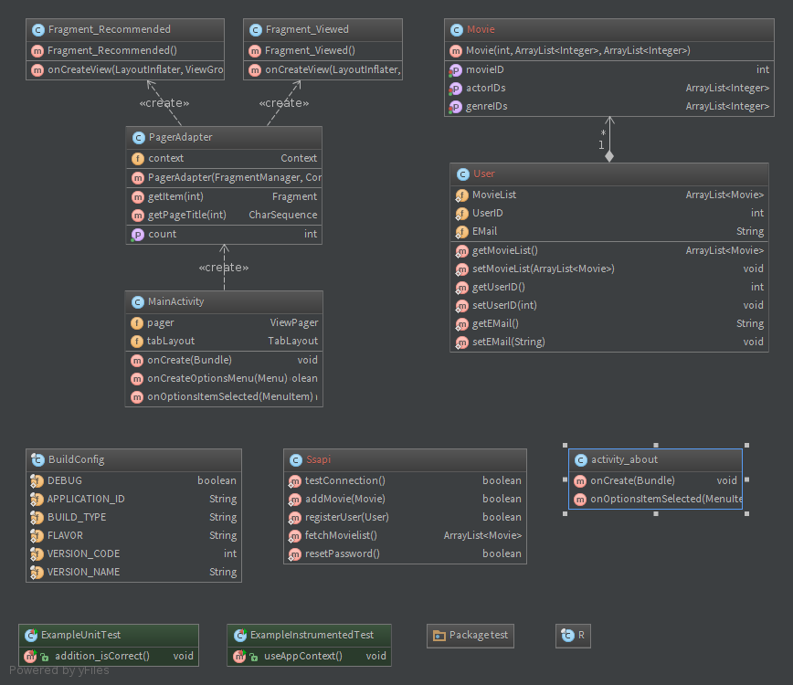

## Layers

TBD

# Data View (optional)

# Size and Performance

TBD

# Quality

TBD